CI/CD Design Documentation

1.Document Overview:
The CI/CD Design Documentation presents the high level design for the implementation of a CI/CD framework that supports the full lifecycle of Data Pipelines, ML Models and Databricks Applications.
The design strategy aims to:
Standardize and automate build, testing and deployment processes across all components.
- Ensure consistency and reliability across Dev, Stage and Prod environments.
- Enable faster release cycles through automated integration, testing and promotion.
- Improve governance, visibility and traceability of code, models and deployments.

2.Background and Context:
Current State Summary:
The current development and deployment practices include:
- One codebase shared across all environments.
- One deployment pipeline in Azure DevOps that handles Dev, Stage, and Prod.
- Environment-specific values stored in dedicated files or key vault references.
- Manual steps in testing and validation.
Identified Gaps:
- Lack of automated testing (integration, data quality, model validation).
- Limited environment governance and approval workflows.
- No templates for applications (databricks apps)
- All environments (Dev/Stage/Prod) currently rely on one unified codebase without environment-specific branching or isolation (Discussed with joshua)

Objective of This Design:
- Unify version control through a single branching model.
- Automate build, test and deploy workflows for Data Pipelines, ML Models and Databricks Applications.
- Enforce quality and governance.
- Improve visibility and monitoring.
Ultimately, this design aims to bring faster, safer and repeatable deployments. By integrating three components under one branching and tooling framework , it ensures quality and scalability across the entire data ecosystem.

3.Design Decisions:
The following design decisions were made to ensure a consistent, scalable, and maintainable CI/CD implementation across all three components — Data Pipelines, ML Models (MLOps), and Databricks Applications:
- Single Branching Strategy (Main Branch- Based Development)
  - Adopted a single main branch (main ) to serve as the source of truth.
  - Developers create short-lived feature branches from the main branch to perform updates or enhancements.
  - Once tested and reviewed, changes are merged back to main, ensuring code consistency and simplified version control.
- Environment Folder Segregation
  - Within the main branch, dedicated folders for each environment — dev/, stage/, and prod/ — are maintained.
  - Environment-specific configurations, infrastructure templates, and deployment logic are isolated to their respective folders.
  - This structure enables environment-level control while maintaining a unified version control strategy.
- Environment-Scoped Identity & Access Control (Service Principals)
  - Three separate Service Principals are used — one for each environment.
    - Each service principal is assigned only the required permissions within its respective Databricks workspace.
    - Dev pipelines authenticate using the Dev SPN, Stage pipelines using the Stage SPN, and Prod pipelines using the Prod SPN.
    - This prevents cross-environment access, enforces least privilege, and ensures auditability for all deployments.
  - This mechanism provides strong separation of duties and protects production resources from unintended changes.

- Unified CI/CD Framework Across Components
  - A common CI/CD pattern is applied across Data Pipelines, ML Models, and Databricks Applications to ensure standardization.
  - All components follow a similar build, test, and deployment lifecycle, orchestrated via Azure DevOps pipelines.
  - Common pipeline templates are used to reduce duplication and improve maintainability.
- Automated Deployment and Controlled Promotion
  - Code merged into main is automatically deployed to the Dev environment.
  - Promotion to Stage and Prod environments occurs via manual approvals or trigger-based workflows in Azure DevOps, ensuring governance and auditability.
- Tooling and Integration
  - Azure DevOps serves as the central CI/CD orchestration platform.
  - Databricks CLI and REST APIs are used for workspace imports, job creation, and deployment automation.
- Scalability and Extensibility
  - The design allows easy extension for new components or environments without impacting the existing workflow.
  - Modular pipeline templates and reusable YAML configurations enhance flexibility.

4.Assumptions:
- Approval Process:
Manual approval requests for promoting code from Dev → Stage → Prod will be handled through Azure DevOps environment gates.
- Service Principals:
A Single Service Principal is currently being used in existing deployment pipelines.
For the new CI/CD design, it is assumed that three separate Service Principals (Dev, Stage, Prod) will be created and assigned appropriate workspace-level permissions.
- Databricks Workspaces:
Dev, Stage, and Prod Databricks workspaces already exist and are accessible for CI/CD deployment.

5.Proposed Solution – Business Overview:
High-Level Approach:
The proposed CI/CD framework includes three key components:
- Data Pipelines
- ML Models (MLOps)
- Databricks Applications

Proposed solution applicable to all components:
- Single Source of Truth:
  - All three are built on a trunk-based single branching strategy, orchestrated through Azure DevOps. All code resides in a single main branch, which serves as the trunk. Developers work on short-lived feature branches derived from main, ensuring that all updates ultimately converge into one consistent codebase.
- Environment-Specific Folders:
  - The main branch contains separate folders for each environment — dev/, stage/, and prod/ — enabling configuration, infrastructure, and deployment logic to be isolated while maintaining a single version control path.
- Automated Promotion Across Environments:
  - Once code is merged into main, Azure DevOps pipelines automatically deploy it to the Dev environment. The same codebase is then promoted to Stage and Prod through manual or approval-based triggers — guaranteeing consistency across deployments.

Business Benefits:
- Scalability & Maintainability: New data sources can be onboarded rapidly using pre-built templates and a metadata-driven approach.
- Reliability & Governance: Centralized logging, metadata, and automated deployment reduce manual errors and improve data reliability.
- Operational Efficiency: A unified monitoring dashboard provides end-to-end visibility, simplifying operations and troubleshooting.

6.Architecture Design
6.1 Data Pipelines
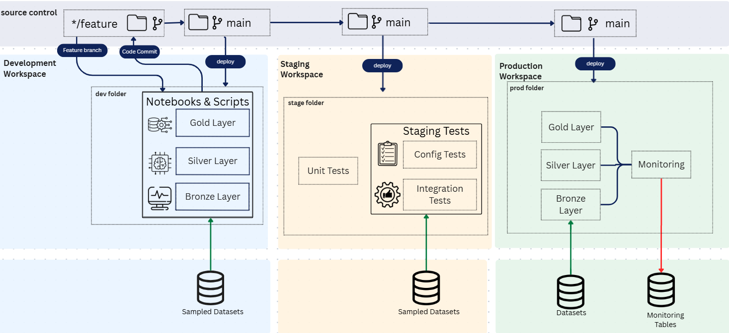
Design Diagram

Component Overview
Development Workspace:
- Work primarily starts in feature directories under dev workspace.
- New or modified pipeline scripts for Bronze, Silver and Gold layers are committed here using sampled datasets.
- The CI process runs initial code checks, packaging (databricks asset bundles)
Staging Workspace:
- Validate code from dev is deployed in the stage environment.
- The CD process executes unit test, configuration tests and integration tests, ensuring schema consistency, dependency validation and data quality
Production Workspace:
- Approved codes are promoted to the prod environment and resources are then deployed in the prod environment.
- Pipeline executes on full datasets, writing to production Delta Lake Tables.
- Continuous monitoring captures job, data quality and performance metrics.
- Alerts and dashboards ensure visibility into pipeline flow and data drifts.

6.2 ML Models
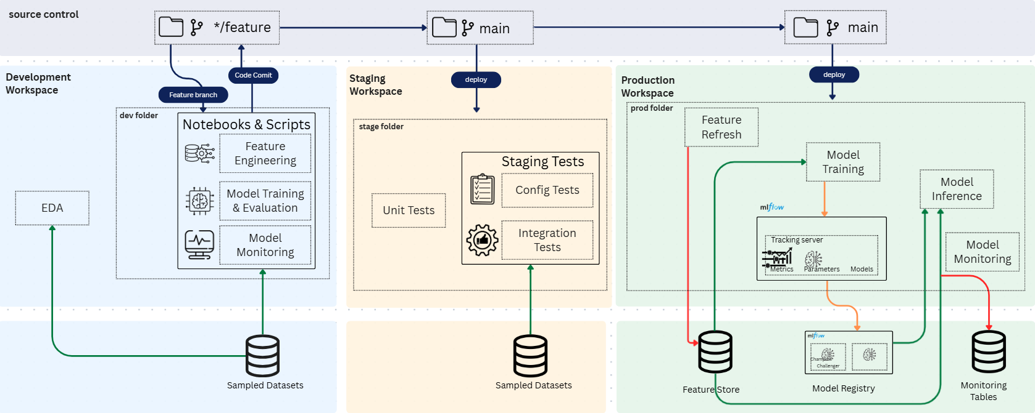
Design Diagram

Component Overview
Development Workspace:
- Data Scientists develop features and train initial models using notebooks.
- Sample or subset datasets are used for rapid experimentation.
- Models can be packaged and deployed within the development workspace for early testing.
- Linting, unit tests, and basic validation checks run locally or in the dev CI pipeline.
- Candidate models are pushed to the Model Registry with preliminary metadata and then deployed to monitor it’s performance.
Staging Workspace:
- Candidate models from development are deployed to staging for comprehensive testing.
- The CD pipeline triggers:
- Linting checks
- Unit tests (data + ML + app logic)
- Configuration tests (env variables, secrets, connections)
- Integration tests validating data pipelines, feature store consumption, and external dependencies
- Multiple models (e.g., champion, challenger) can be deployed simultaneously for comparison.
- Staging is used to evaluate performance on richer, production-like datasets and environment parity.

Production Workspace:
- Production feature store is refreshed on live/production data.
- Promoted code is re-trained using the production feature store via MLflow pipelines.
- The best-performing model from the training run is registered in Unity Catalog.
- Champion and Challenger Models:
Tagging logic determines which model becomes Champion and which becomes Challenger.
Logic can be implemented based on Denso SME preference:
  - Automated based on ML metrics (accuracy, F1, MAPE, drift score, etc.)
  - Manual override where SMEs or Data Scientists compare results and assign tags based on business preference
- Registry metadata stores champion/challenger status for auditing and deployment flows.
- The chosen model is deployed using Model Serving, and Inference Tables are enabled for continuous monitoring.
- Monitoring tracks performance, drift, input data stability, and operational health.
- Alerts are triggered on performance degradation, drift breaches, or serving failures.

6.3 Databricks Applications
Component Overview
Development Workspace:
- Developers build and test dashboards, workflows, and scripts in the Dev workspace.
The Dev CI process performs:
  - Code linting and formatting checks
  - Configuration validation
  - Dependency checks
  - Basic unit tests using sample/mock data
- The application is deployed in Dev to confirm basic functionality.
Staging Workspace:
- The application is promoted to Stage for deeper testing.
The Stage CD process validates:
  - End-to-end app functionality
  - Notebook/script imports
  - Data and API integration checks
  - Basic UAT with staging data
- The application is deployed in Stage to ensure it works correctly with near-production data.
Production Workspace:
- Once validated, the app is deployed to Production.
Production deployment includes:
  - Publishing dashboards and workflows
  - Job scheduling
  - Connecting to production data
  - Setting up alerts and monitoring
- The application is finally validated in Prod using real production data.

7.Testing & Validation

Test Type | Layer | Description | Tools
 |  |  | Python - Pylint  SQL - SQLFluff or SQLint
  Linting
  Data, ML, App
  Ensures code quality,
  style consistency,
  and detects syntax
  or logical issues
  before execution.
Unit Tests | Data, ML, App | Validates individual functions or transformations | PyTest
Integration Tests | Data, ML | Ensures model consumes correct data, validate dependencies and configurations | Scripts
Configuration Tests | All | Verifies environment variables, connections and secrets | Azure DevOps
Model Validation | ML | Validates model accuracy, drift and performance threshold | MLflow
Post Deployment Tests | All | Runs smoke tests after deployment | Azure DevOps Pipelines

Implementation Plan:
- Linting, Unit, and Integration Tests: These will be implemented in Azure DevOps Pipelines for continuous testing and feedback.

- Configuration Tests, Model Validation, and Post Deployment Tests: These will be handled inside the deployment bundle to validate the system after deployment to staging or pre-production.

8.Automation and Alerts
Automation:
- Azure DevOps Pipelines automate build, test and deploy.
- Databricks CLI automates workspace imports and job execution.

Alerts:
- Pipeline failures trigger email or notifications.

9.Deployment Design
Deployment to each environment is controlled through folder-based triggers and environment-specific pipelines:
Environment | Trigger | Target Workspace | Deployment Type
Dev | Push to dev/ | Dev Workspace | Automatic deployment
Stage | Push to stage/ | Stage Workspace | Automatic + Approval
Prod | Push to prod/ | Prod Workspace | Manual + Approval
This ensures structured promotion of code, proper governance, and environment-level control across the CI/CD lifecycle.

10.Appendix

Tools & Technologies:
- Azure DevOps (Repos, Pipelines, Artifacts)
- Databricks (Workspace, Jobs, Apps)
- MLflow
- Python

References:

